MARCQ EN BAROEUL - FRANCE / November 22nd, 2022

Lesaffre reinforces its presence in Australia

Lesaffre Australia Pacific, subsidiary of the Lesaffre in Australia, inaugurated in mid-November, two new facilities: a Molasses Extracts Plant (MEP) on its production site in Melbourne and enhancements in the existing Baking Center™ in Mortlake Sydney, a showroom that train in the art of breadmaking.

For Lesaffre, the strengthening of its presence in the region illustrates the Group’s desire to reinforce its geographical footprint throughout the world and to make the most of the molasses derivatives in a circular economy.

" Lesaffre has been present in Australia for almost 30 years, both commercially and through our yeast production plant near Melbourne. Through the setting up of this workshop for the valorization of our yeast derivatives, and the improvement of our Baking Center™, Lesaffre is confirming a model that is part of its identity: to be a privileged partner to our customers and to offer them high quality products that respect the environment,” says Jean-Philippe Poulin, Chief Operating Officer and Group Deputy CEO.

A Molasses Extracts Plant to produce advanced derivative products

In addition to baking yeasts direct applications aimed at nutrition and health, its manufacturing process allows Lesaffre to collect derivative products rich in nutrients, which are then reprocessed by evaporation. The applications are very diversified and respectful of the environment.

The MEP is dedicated to the treatment of those derivatives that are usually recovered in liquid form for spreading on horticultural crops. Derivative products represent solutions to reduce the use of mineral fertilizers essential for industrial agriculture. Response from local industry to these products has been strong due to safe and climate smart solutions, for which there are limited market alternatives.

Whilst Lesaffre Australia Pacific commercialized derivative products over a decade ago in the soil nutrition sector, the development of the MEP process represents an opportunity for new technical market applications in a range of industries. These include ruminant nutrition, industrial dust suppression, pelletizing, cardboard manufacturing and even in dishwasher tablets. Lesaffre is excited to introduce this technology to the Australian market while simultaneously maximizing product quality, versatility and handling efficiency.

"Our MEP is a great tool to manufacture premium and innovative products. Through this new facility located in the heart of our production unit, we now can propose innovative and sustainable solutions to numerous technical and agri-applications whilst substantially reducing the impact of our plant on the environment and on our wider community” says Robert Arvier, Project Director (Agribusiness), Lesaffre Australia Pacific.

Decision to invest in the new facility was taken in 2019 following engagement with relevant local government agencies as part of the wider future proofing strategy deployed by Lesaffre. Despite the challenges of Covid, the plant was built in 18 months and it will reach its full capacity in November 2022.

This is the first installation of its kind by Lesaffre in Australia, and the 20th installation of its kind globally. In Australia, the group has had a manufacturing presence since 1995 and employs over 65 people.

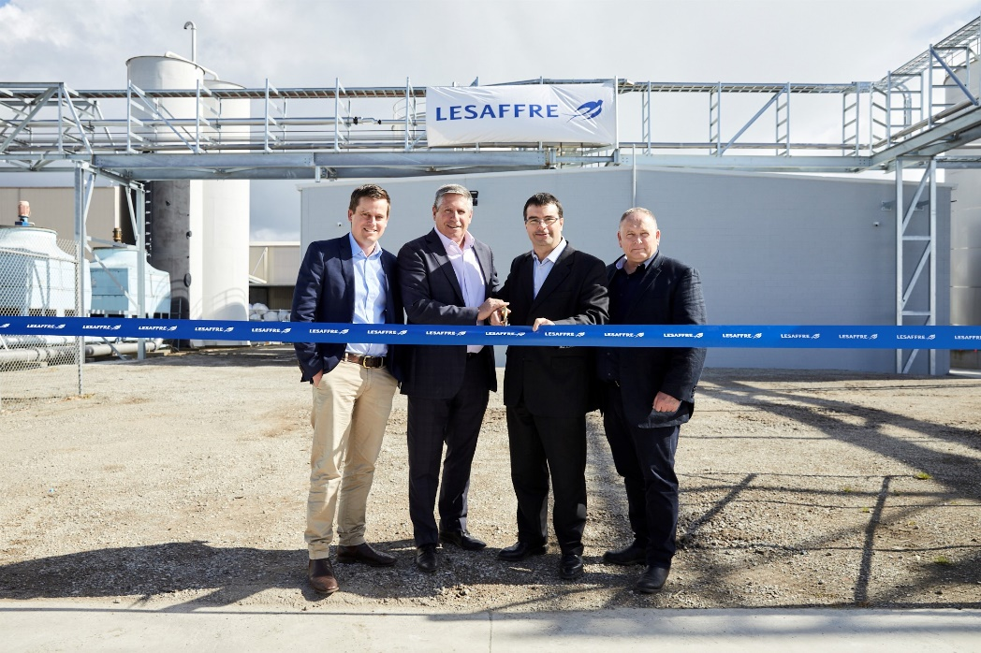
Robert Arvier, Project Director – Agribusiness, Lesaffre Australia Pacific; Barry Sohier, General Manager, Lesaffre Australia Pacific; Timothe Dupont, Managing Director, Lesaffre Asia Pacific Breadmaking Region; Jake Norton, Operations Manager, Lesaffre Australia Pacific.

Upgraded and expanded Baking Center™

During this time, Lesaffre Australia Pacific also unveiled new improvements and equipment to its existing Baking Center™. The setting up of this Baking Center™ is part of a network expansion strategy to support customers in the development of their expertise and offer the much-needed exposure to new, disruptive, innovative baking solutions.

"We opened a Baking Center™ in Australia a few years ago, which met a real success with bakers. The enhancements to this existing unit will allow us to further support our customers in the art of breadmaking and will enable us to offer more precise and global technical applications to current & future customers, such as technologies regarding reduction of energy consumption or new cooking techniques” says Barry Sohier, General Manager, Lesaffre Australia Pacific.

Lesaffre now has a network of nearly 50 Baking Center™ dedicated to welcome clients from all backgrounds, including master bakers, industrial producers, distributors and R&D teams.

Those centers are fully designed to pave the way for new processes and ingredient formulations that improve baking, as well as new yeasts and sourdoughs. Through various training courses, Baking Center™ facilities encourage joint projects and create enduring relationships based on trust.

The Baking Center™ concept was pioneered in 1974 by Lesaffre to meet and answer baking customer needs. Today the international network operates as a referent in baking fermentation. For almost 50 years, it has expanded its expertise and know-how to its customers: market knowledge, innovation, formulation, sensorial analysis, scientific support, technical assistance, and trainings. Every day, more than 300 technical bakers work as co-innovators with customers to develop the baking processes and products of tomorrow.

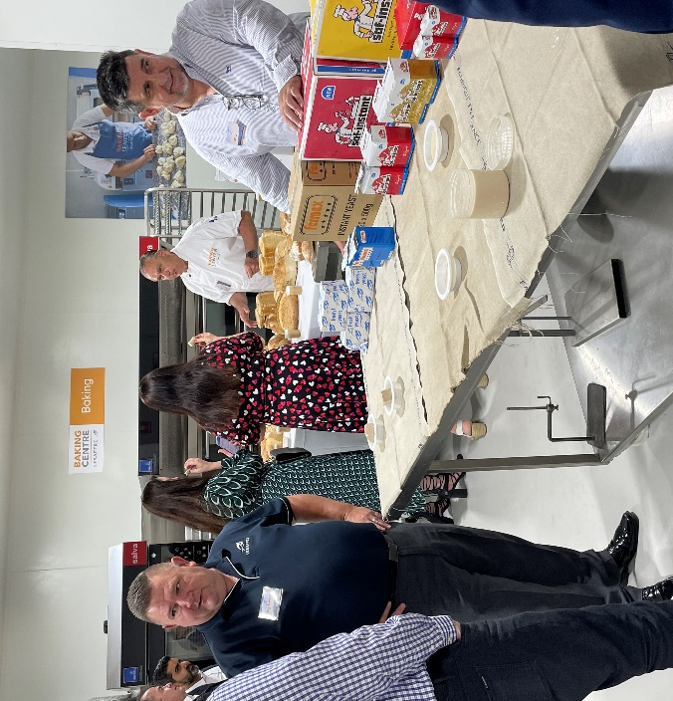

Lesaffre Australia Pacific Baking Center™ Mortlake Sydney

about Lesaffre

A key global player in fermentation for more than a century, Lesaffre, with a 2,2 billion euro turnover, and established on all continents, counts 11,000 employees and more than 85 nationalities. On the strength of this experience and diversity, we work with customers, partners and researchers to find ever more relevant answers to the needs of food, health, naturalness and respect for our environment. Thus, every day, we explore and reveal the infinite potential of microorganisms.

To nourish 9 billion people, in a healthy way, in 2050 by making the most of our planet’s resources is a major and unprecedented issue. We believe that fermentation is one of the most promising answers to this challenge.

Lesaffre – Working together to better nourish and protect the planet

More information on www.lesaffre.com
Join us in conversation on LinkedIn and on Twitter

