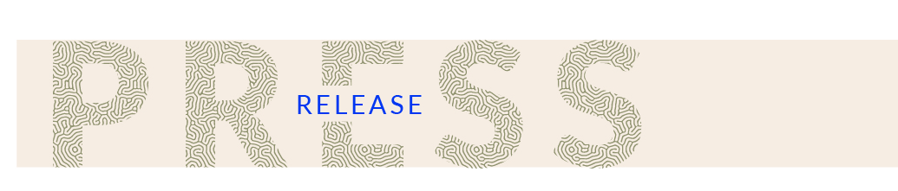

MArquette-lez-lille – France – MAY 2nd, 2023

Fermentis by Lesaffre inaugurates its new Campus on the Lesaffre historical site in Marquette-Lez-Lille

Fermentis by Lesaffre, a Lesaffre business unit dedicated to fermented beverages such as beer, wine and spirits, inaugurated its new Campus on Tuesday May 2nd, 2023. This 3,000 m² space brings together in a single location all employees in the Lille metropolitan area dedicated to this activity. Located in Marquette-Lez-Lille, on the historic site of the Lesaffre grain alcohol and genever distillery founded in 1853 by Louis Lesaffre and Louis Bonduelle, the group's co-founders, it also houses several facilities for research and training.

The Fermentis Campus officially opened its doors in March 2022, after two years of construction. This new space includes 3,000 m2 of interior space that brings together the company's fifty or so employees based in the Lille metropolitan area and houses new facilities including a brewery with more than 50 fermenters, laboratories, partly dedicated to sensory analysis, and a reception and training centre. The exterior is decorated with green spaces, where hop fields, vines and an orchard have been planted.

LESAFFRE'S HISTORY AT THE CORE OF THIS CAMPUS

The Fermentis Campus is located on a historic Lesaffre site: the grain alcohol and genever distillery founded in 1853 by Louis Lesaffre and Louis Bonduelle, co-founders of Lesaffre.

On this site, industrial alcohol from corn, rye and barley was produced for companies, as well as genever alcohol under the name Alcool de l'Abbaye.

In 1923, following the French government's decision to drastically reduce the purchase price of grain alcohol, the site was transformed into a malting plant under the name "Grandes Malteries Modernes". It was the home of this activity until 2006. At that time, Lesaffre separated itself from this activity in order to concentrate on the production of yeast, micro-organisms and other fermentation products.

Lesaffre has always wanted to reinvest in this emblematic site in its history. This is how it was rehabilitated into a place dedicated to yeasts and other micro-organisms for fermented beverages to become the Fermentis Campus, which is being inaugurated today.

To commemorate the founders of the group and to respect the spirit of the place, the facade of the old distillery was preserved.

Some of the grain silos of the former malt house were retained, although they presented a difficult challenge for the architects. More generally, the industrial history of the region and the site influenced the choice of materials: concrete, brick, glass, wood, metal, leather.

A PLACE FOR RESEARCH AND EXPERIMENTATION, BOTH TECHNICAL AND SENSORY

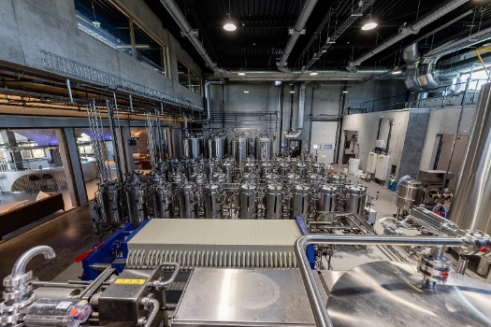
Inside the Campus, a state-of-the-art pilot infrastructure for the production of fermented beverages has been installed. This technical hall was designed to test yeasts, bacteria, and yeast derivatives under thousands of different conditions. This location has several dozen fermentation tanks equipped and connected to best monitor and analyze the fermentation processes. Additional tanks allow visitors to observe fermentation in real-time.
THE WATCHWORDS: GATHER, SHARE, TRANSMIT

Located in Marquette-Lez-Lille, the Fermentis Campus is situated at a strategic crossroads, easily accessible from Paris (1 hour), Brussels (35 minutes by train) or London (1 hour 20 minutes).

A sensory analysis laboratory, run by a sensory analyst, is also part of the tools available. Through three panels of tasters (about 50 people) trained and supervised to express what they feel during tasting, it is in this laboratory that the physico-chemical indicators make sense for everyone. Equipped with a sample preparation room and a tasting room with 17 boxes, it allows tests to be carried out in optimal conditions.

In addition to sensory analysis, tests will be carried out daily in two additional laboratories (one for microbiological analysis, the other for physico-chemical analysis), adjacent to the technical room.

The Fermentis Campus also has an amphitheater that can seat up to 160 people. Numerous Fermentis Academy training sessions are held here. An application centre dedicated to the fermented beverages business, the Fermentis Academy has been designed to welcome and train players in the world of fermentation in the art of using Fermentis by Lesaffre solutions.

Whether through market knowledge, explanation of innovation, formulation, sensory analysis, scientific support, technical assistance, or training, it is in a spirit of sharing and exchange that proximity with customers is built.

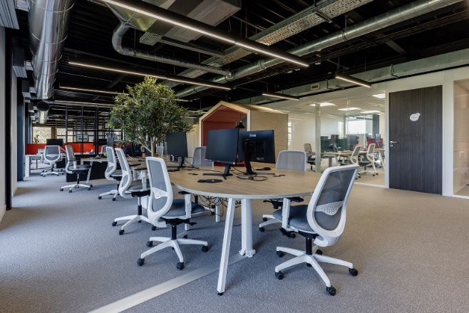
All expertise is gathered on the first floor of the Campus: technical sales, R&D, marketing and communication, supply chain, finance, legal and regulatory. Designed to encourage teamwork, freedom and movement, the office space facilitates the relationship with Fermentis' clients on a daily basis. The furniture, the flexible spaces, the terrace, the lounge, but also the light, the view on the outside and the nature... Everything has been designed to create a pleasant and stimulating atmosphere.

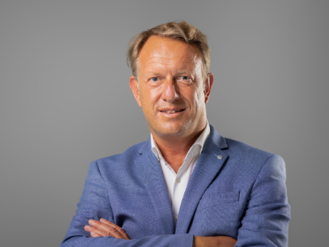
"Fermentis celebrates its 20th anniversary in 2023. In twenty years, the world has changed considerably. We ourselves have evolved rapidly. Our Campus is undoubtedly a reflection of who we are today and what we want to achieve. This is reflected in the expertise of our teams, the technical and architectural facilities in which we have invested, and the ambition of a place that is open to others, as widely as possible. This Campus, designed for our clients and partners to interact with them and accompany them, reflects our values of hospitality, conviviality and commitment.” Stéphane Meulemans, Managing Director of Fermentis.

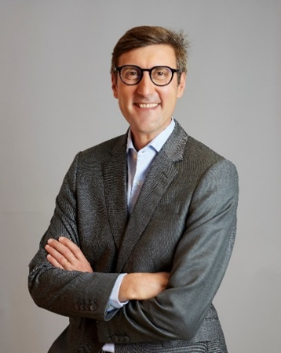
"The inauguration of the Fermentis Campus is a milestone in the history of Lesaffre. It is in keeping with the group's identity: an innovative place that encourages meetings and is a synthesis of our research and industrial know-how. The state-of-the-art equipment made available to the Fermentis by Lesaffre teams, and the Fermentis Academy give them the opportunity to work to develop and maintain proximity with our customers. For 170 years, we have been growing and evolving alongside them. With this new Campus, which perfectly combines history and cutting-edge technology, our Group is reaffirming its position as a major world player in the field of fermentation and micro-organisms, while proudly displaying its glorious heritage and its capacity for innovation.” Brice-Audren Riché, Lesaffre CEO.

about Lesaffre

A key global player in fermentation for more than a century, Lesaffre, with a 2,7-billion-euro turnover, and established on all continents, counts 11,000 employees and more than 96 nationalities. On the strength of this experience and diversity, we work with customers, partners and researchers to find ever more relevant answers to the needs of food, health, naturalness and respect for our environment. Thus, every day, we explore and reveal the infinite potential of microorganisms.

To nourish 9 billion people, in a healthy way, in 2050 by making the most of our planet’s resources is a major and unprecedented issue. We believe that fermentation is one of the most promising answers to this challenge.

Lesaffre – Working together to better nourish and protect the planet.

More information on www.lesaffre.com
Join us in conversation on LinkedIn and on Twitter

