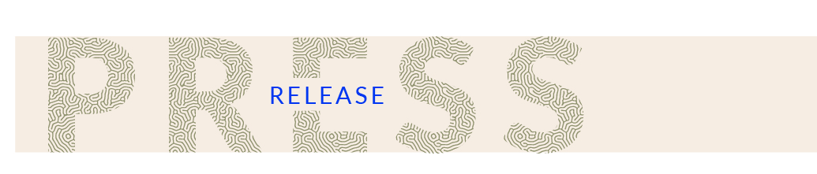

MArcq en Baroeul – France - and Malang– IndonEsIa – february 29th, 2024
Lesaffre welcomes its clients and partners to its new yeast plant in Indonesia, strengthening its presence in Asia Pacific

Lesaffre, a 170-year-old global key player in fermentation and microorganisms, welcomes today its clients and partners to its new plant in Indonesia dedicated to the production of compressed and dry yeast.

Lesaffre has been commercially active in Indonesia for over 40 years. PT Saf Indonusa, Lesaffre’s first Indonesian subsidiary incorporated in 2000 today employs more than 130 employees through its baking ingredients blending plant in Surabaya, Jakarta head office and four Baking Center™ and sales offices in Jakarta, Medan, Semarang, Surabaya. The new plant completes the already active blending plant for baking ingredients in the Surabaya region.

With this new plant, built on a 9.8 ha land in Malang Regency, East Java, Lesaffre is strengthening its geographical footprint close to its customers. It will supply baking yeast in Indonesia and ASEAN countries.

This new entity, PT Lesaffre Sari Nusa, is a partnership between Lesaffre and its Indonesian long lasting partner PT Citra Bonang. More than 200 new local positions have been created to run the new plant.

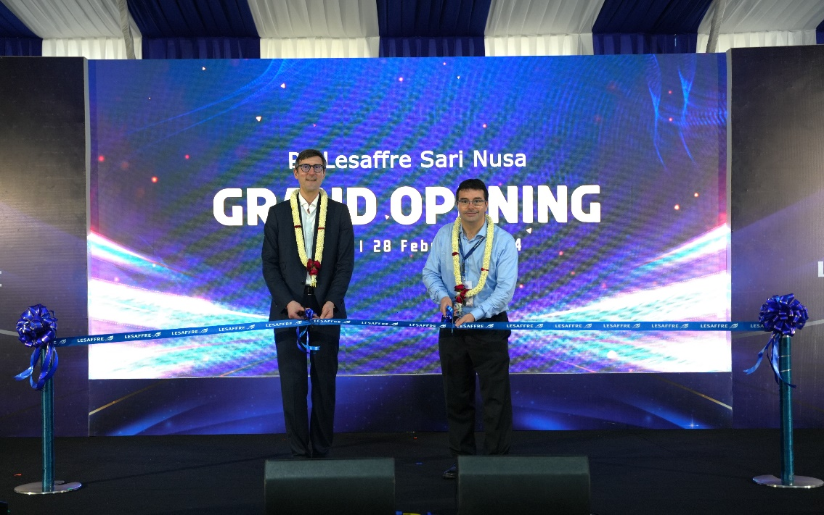

"Lesaffre has been present in the Asia Pacific region for more than 55 years. This new plant in the region illustrates our determination to provide our clients with the best possible support and to meet their needs with innovative solutions. By welcoming our clients and partners to our new plant in Malang, Indonesia, we affirm once again Lesaffre’s desire to evolve and grow alongside its customers, in a spirit of partnership.” says Brice-Audren Riché, Lesaffre CEO.

In line with the group’s approach regarding reduction of the environmental impact of the production, the new plant integrates a complete post-production workshop to valorise the residual part of the substrates: once production of yeast has been completed, the fermentation wort is further processed into a range of co-products used as fertilizers and for animal feed.

"By combining state-of the art technologies and Lesaffre industrial know-how of excellence on this new site, we are able to provide best quality yeast to our markets in Indonesia and throughout the Asia Pacific region where demand is growing. This new factory allows Lesaffre to better than ever accompany its clients in their growth, with an enhanced proximity, " analyses Timothé Dupont, General Manager of Lesaffre Breadmaking Asia Pacific Region.

With a growing portfolio of innovative products and solutions that serve consumers, Lesaffre is adopting an increasingly "customer-centric" approach. For example, Lesaffre was the first company to create, in 1974, application centers to train and work alongside bakers, striving to always perfect the art of bread-making: the Baking Center™. Today, spread across 51 Baking Center™ around the world, the group's multicultural technicians and experts capitalize on their knowledge of local markets to support our customers in all phases of their projects.

Since the Group creation in 1853, the ambition to have a strong industrial footprint has always been at the heart of Lesaffre's development and growth, through the extension of its presence worldwide. Thanks to a resolutely local approach and the diversification of its area of expertise, the Group has developed alongside its customers by anticipating their changing needs, regardless of their profile, from craft to industrial bakeries.

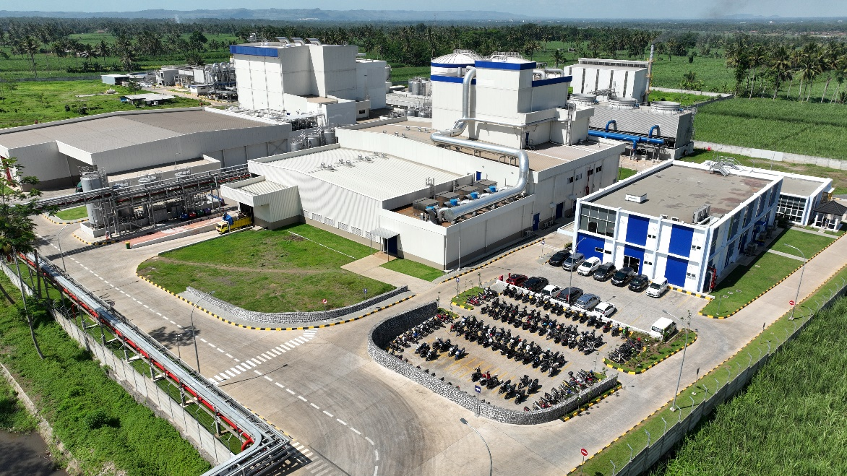

about Lesaffre

A key global player in fermentation for more than a century, Lesaffre, with a 2,7-billion-euro turnover, and established on all continents, counts 11,000 employees and more than 96 nationalities. On the strength of this experience and diversity, we work with customers, partners and researchers to find ever more relevant answers to the needs of food, health, naturalness and respect for our environment. Thus, every day, we explore and reveal the infinite potential of microorganisms.

To nourish 9 billion people, in a healthy way, in 2050 by making the most of our planet’s resources is a major and unprecedented issue. We believe that fermentation is one of the most promising answers to this challenge.

Lesaffre – Working together to better nourish and protect the planet.

More information on www.lesaffre.com
Join us in conversation on LinkedIn and on Twitter

